CTM-I Use Case

Drop Copy

(Change/Delete)

Version 0.1

Use Case Name | Drop Copy
Actor | Market Ops, Operations, App Support
Pre-conditions /Assumptions | User has Browser and is aware of the http path to the application.  User has successfully logged into the CTM-I application.  User has the right role to see the menu options.
Post Conditions | None
Screenshot | 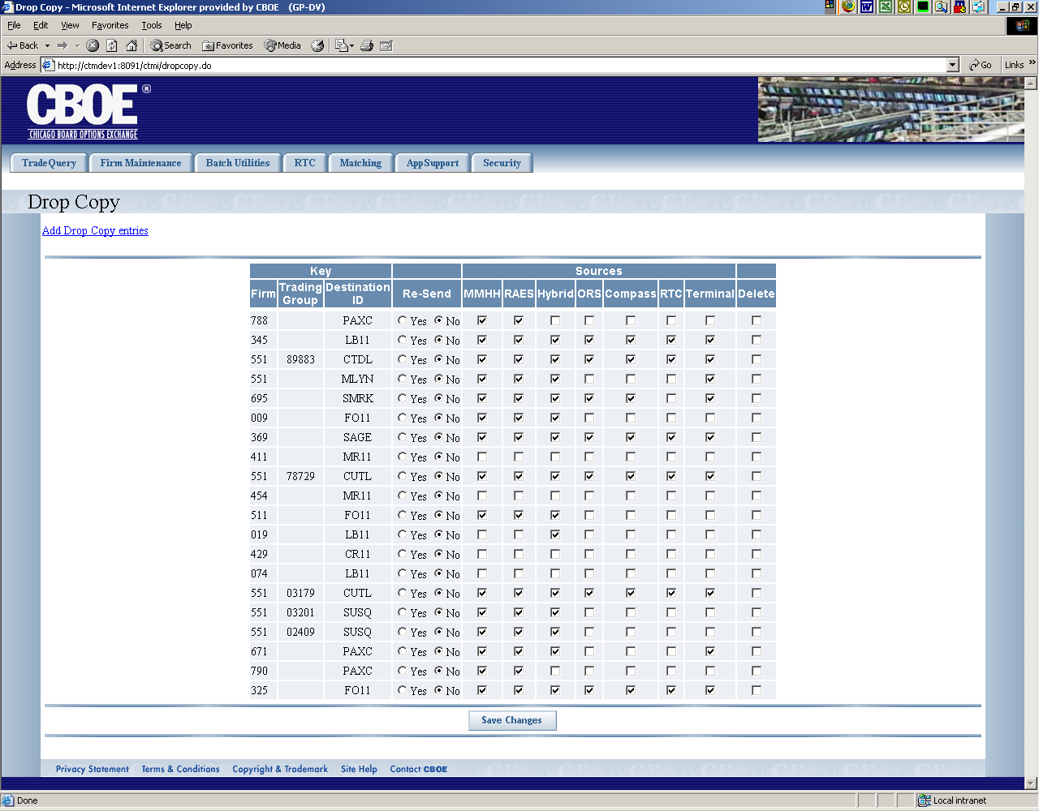
Flow of Events | - User selects “Drop Copy” from the menu.  - A request is sent to CTM-R to get all the drop copy records to display  - The Drop Copy screen appears with all the data displayed in a table  - All rows of the table will be displayed, no paging will be done  - The data show on each row will be as follows  - Firm (read-only for edit, enterable for add)  - Trading Group (read-only for edit, enterable for add)  - Destination ID (read-only for edit, enterable for add)  - Re-Send (Options for Yes and No)  - Market Maker Handheld (either Y or N)  - RAES (either Y or N)  - Hybrid (either Y or N)  - ORS (either Y or N)  - Compass (either Y or N)  - RTC (either Y or N)  - Terminal (either Y or N)  - The user will have the ability to mark a row for deletion. When the user clicks to mark a row for deletion, a pop-up will ask the user to confirm the delete.  - The user presses the “Save Changes” button to save the changes made  - Any records added will have the following defaults set in the record  - Transactions Add, Change, Delete and Dec will be set to “Y”  - The changes will be sent to CTM-R for processing  - The results of the CTM-R processing will be displayed to the user.  - There will be a link to Drop Copy add, where the user can add new drop copy entries. The user case is the same except for the firm, trading group and destination ID field will be enterable and the pop-up to ask user to confirm will not be coded.  - After adding a drop copy entry the user is taken back to the display screen of Drop Copy.
Alternative Path | 1.1 List Alternative Flows Here.

